LAB PROGRAMS

NAME: M.SAI HARSHITHA
REG.NO: 192424408
COURSE CODE: DSA0502
COURSE NAME: QUERY PROCESSING FOR DATASCIENCE

1. Write a Pandas program to select the distinct department id from employees file.
Aim:
To write a Pandas program to select the distinct department IDs from the employees file.
Algorithm :
- Import the Pandas library.
- Create an employees DataFrame.
- Save the DataFrame as a CSV file.
- Read the CSV file.
- Display the employee data.
- Select the department_id column and find the distinct values.
- Display the distinct department IDs.
Code:
import pandas as pd
employees = pd.DataFrame({
"employee_id": [101, 102, 103, 104, 105],
"employee_name": ["John", "Alice", "Bob", "David", "Eva"],
"department_id": [10, 20, 10, 30, 20]
})
employees.to_csv("employees.csv", index=False)
df = pd.read_csv("employees.csv")
print("Employees Data:")
print(df)
distinct_departments = df["department_id"].unique()
print("\nDistinct Department IDs:")
print(distinct_departments)
Output:
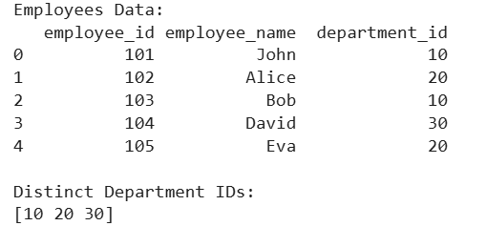

2. Write a Pandas program to display the IDs of employees who have done two or more
Aim:
To write a Pandas program to display the IDs of employees who have done two or more jobs.

Algorithm :
- Import the Pandas library.
- Create an employee jobs DataFrame.
- Save the DataFrame as a CSV file.
- Read the CSV file.
- Display the employee job data.
- Count the number of jobs done by each employee.
- Display the IDs of employees who have done two or more jobs.

Code:
import pandas as pd
employees = pd.DataFrame({
"employee_id": [101, 102, 101, 103, 102, 104, 105],
"job_id": ["J01", "J02", "J03", "J01", "J04", "J05", "J06"]
})
employees.to_csv("employees_jobs.csv", index=False)
df = pd.read_csv("employees_jobs.csv")
print("Employee Job Data:")
print(df)
job_count = df.groupby("employee_id").size()
employee_ids = job_count[job_count >= 2].index
print("\nEmployee IDs who have done two or more jobs:")
print(employee_ids.tolist())

Output:
